The times in these transitions are clearly determined by load, capacitive or resistive, driven by an inverter. Hence it is important to determine this load. Primary timing comes from capacitive load and hence we will only consider this.
Load capacitance estimation

2
1
3
1
2

When a CMOS gate drive another CMOS gate, the driver "sees" a capacitive load. The load capacitance consists of (1) gate capacitance of the load, (2) diffusion capacitance of the driver, and (3) the routing capacitance.

Intrinsic Capacitances of MOS

C_{gd}
C_{db}

C_{sb}
C_{gs}

C_{gb}
(Identify these capacitances from p. 4 MOSFET structure)
Gate Capacitance
When transistor is "OFF", there is no channel, there are two dielectric regions below gate – oxide (gives capacitance C_{o}) and space charge region (gives capacitance C_{SC}) in the substrate as shown. C_{gs} = C_{gd} = 0. ε_{SiO2} and ε_{Si} are dielectric constants of oxide and silicon, respectively. A is area of the channel region (=WL), W being the MOSFET width and L MOSFET length.

C_{gb} = C_{o} in series with C_{sc.}

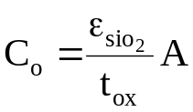
t_{ox}
C_{o}
space charge layer
d
C_{sc}

For 0 < V_{gs} < V_{th} , a depletion layer of depth d is formed in the substrate.

C_{gb} =
C_{o}
C_{sc}

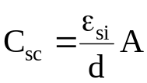 and decreases with increasing V_{gs}.

Hence C_{gb} decreases with increasing V_{gs} as d increases. However, this is generally simplified so that

C_{gb} = C_{o}.

In the linear region, a continuous channel from source to drain is formed. The gate to channel capacitance is 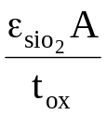.
Let 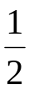 of this be C_{gs} and the other half be C_{gd} . Hence ,
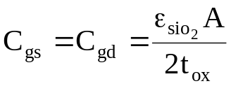

In the saturation region , the drain region of the channel is pinched-off . Here C_{gd} = 0 and 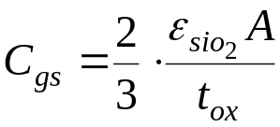.

Parameter | Capacitance
Parameter | Off | Linear | Saturation
C_{gb} | 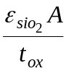 | 0 | 0
C_{gs} | 0 | 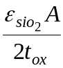 | 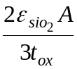
C_{gd} | 0 |  | 0

Diffusion capacitance
diffusion
C_{jp}
C_{ja}
peripheral
area
substrate

Peripheral capacitance is determined by the perimeter of Source or Drain.

Zero bias capacitance
Parameter | n-diffusion | p-diffusion
C_{ja0} | 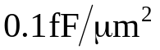
C_{jp0} | 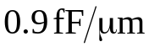 | 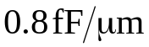

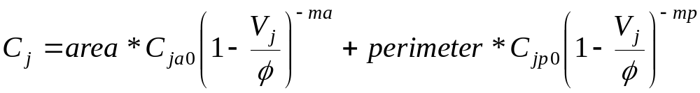

V_{j} = junction voltage. (+ve for forward bias.
-ve for reverse bias (MOS case).)
= built-in junction potential ≈ 0.6-0.9 V
ma, mp = 0.3 ~ 0.5
Routing capacitance

Representative CMOS Values

Capacitance
Gate (Cox) 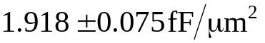

Poly2 to Substrate 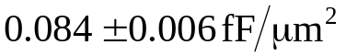

Poly1 to Poly2 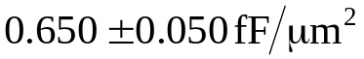

Metal1 to Substrate 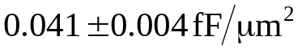
Metal1 to Diffusion 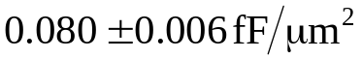
Metal1 to poly2 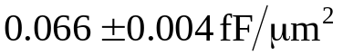

Metal2 to Substrate 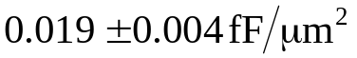
Metal2 to Diffusion 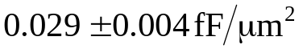
Metal2 to Poly2 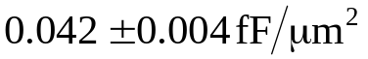
Metal2 to Metal1

Another important parameter to extract is the resistance of various regions. We will not use it in simple calculations but it is used in accurate simulation.

Sheet resistance

l
w
t

Resistance of a uniform slab

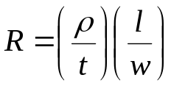 , 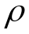 = resistivity

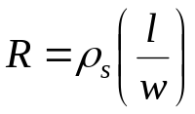
sheet resistivity

 | sheet resistance 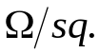
material | min. | typical | max.
n well  n⁺  p⁺  poly 1  poly 2  metal 1  metal 2 | 1150  47  85  17.5  15  0.066  0.033 | 1300  57  100  22.5  20  0.072  0.036 | 1450  67  115  27.5  25  0.078  0.039

Sheet resistivity of transistor channel in the linear region

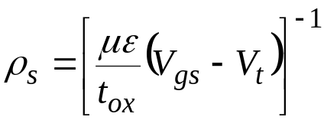

Timing Calculation
We will simplify this assuming a fixed load capacitance.
V_{DD}

C_{L}
v_{in}
v_{o}
0V

v_{in}
v_{DD}
t_{d}
0V
v_{DD}
v_{o}
0.9v_{DD}
0.5v_{DD}
0.1v_{DD}
0V
t_{r}
t_{f}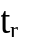

t_{d} : delay time
t_{f} : fall time
t_{r} : rise time

Fall time (time for V_{o} to fall from 0.9V_{DD} to 0.1V_{DD}) , t_{f}

I_{ds}
V_{o}
V_{o}
R
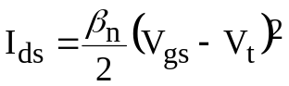
V_{gs} = V_{DD}
saturation
linear

For V_{o} = 0.9V_{DD} NMOS in Saturation , V_{o} > V_{DD} - V_{t} : V_{o} drops from 0.9V_{DD} to V_{DD} - V_{t}

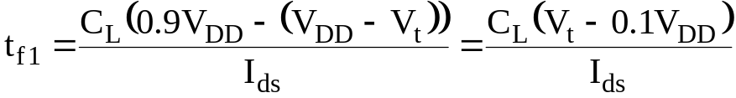
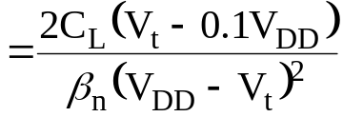

For V_{t} = 0.2 V_{DD}

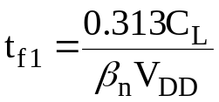
For V_{o} < V_{DD} - V_{t} , NMOS in Linear region : V_{o} drops from V_{DD} - V_{t} to 0.1V_{DD}
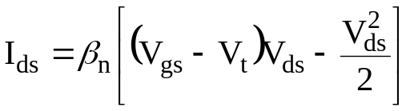
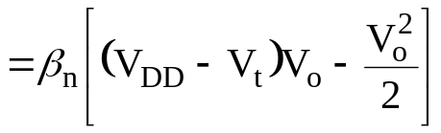
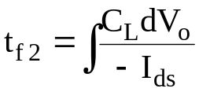
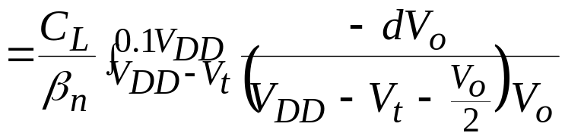
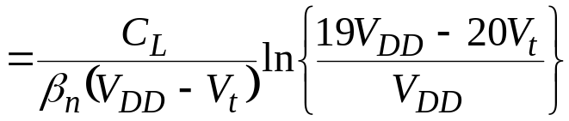
For V_{t} = 0.2 V_{DD}
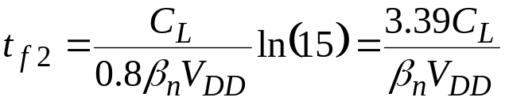
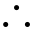 fall time, 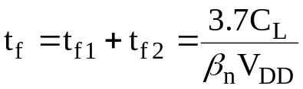
If β_{p} = β_{n} , rise time = fall time, same condition that is required for right switching voltage. This is thus normally adopted.

Delay time , t_{d}
Saturation : V_{o} drops from V_{DD} to V_{DD} - V_{t}
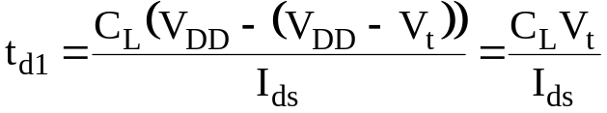
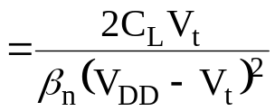
For V_{t} = 0.2 V_{DD} , 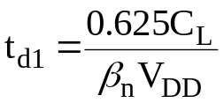
Linear : V_{o} drops from V_{DD} - V_{t} to 0.5 V_{DD}
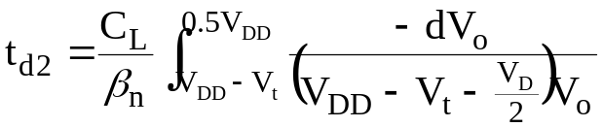
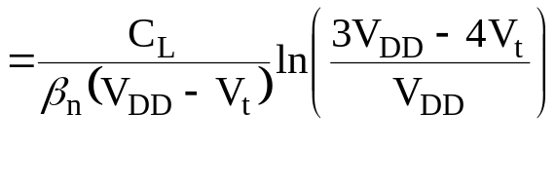
For V_{t} = 0.2 V_{DD} , 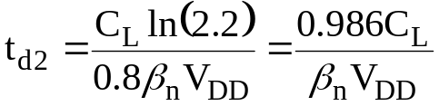
delay time 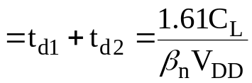
Technology Innovation? How to reduce these delays and get faster circuits?
Hence for a fixed load, W of the devices can be increased to achieve the right required delay. Such fixed capacitances are normally dominated by the interconnect capacitance.
However, if device W is increased, the area of the channel (WL) and area/perimeter of source/drain also automatically increase. Hence the previous stage now has to drive a larger intrinsic gate capacitance load. This needs to be tackled right so that the delay can be minimised. The issues are explained in the following section.

Driving intrinsic large capacitance load
Let input capacitance seen at the gates of inverter sized for equal rise and fall time i.e.
both transistors have β_{n} = β_{p} = β where β is a given constant.
β
C
C

delay = τ_{o} = K C ⁄ β, where K is a constant.
β
delay = K (100C) ⁄ β= 100 τ_{o}
100 C
C
One may think that by increasing β_{n} = β_{p} by a factor of 100 to 100 β will reduce the delay to τ_{o}. However, the capacitance seen at the input now becomes 100C as the gate area also increases by the factor 100 and delay at the input stage will now rise. Hence this basically transfers delay issue to the input. Hence a better strategy will be to drive using a chain of progressively growing inverters to obtain minimum delay as shown below.
Here, for the last stage, the load is 100C, β_{n} = β_{p} = 10β. Hence the delay of the last stage = K*100C/(10β) = 10KC/β = 10 τ_{o}. For the first stage, load is 10C and
β_{n} = β_{p} = β. Hence the delay of the first stage = K*(10C)/β = 10KC/β = 10 τ_{o}. The delay of every stage is similarly calculated.
β
10β
delay = 10 τ_{o} + 10 τ_{o}
10C
= 20 τ_{o}
100 C
C

β
9β
30β
delay = (3 + 3 +3.3 +3.3)τ_{o}
3β
= 12.6 τ_{o}
100 C
C
3C
9C
30C
64β
β
2β
4β
8β
8C
100 C
16β
32β
16C
32C
64C
C
2C
4C

delay = (2 + 2 + 2 + 2 + 2 + 2 + 1.6) τ_{o} = 13.6 τ_{o}
Now look at a general problem with load = MC.
β
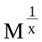β
C
MC
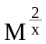β
x stages

Total number of stages is x and each inverter size grows by a factor 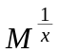 . Hence load for the first stage will be C and it will progressively grow by a factor. Hence for any arbitrary n^{th} stage, the load capacitance will be C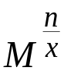 and size factor will be 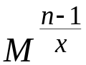β. Hence the delay of the n^{th} stage is
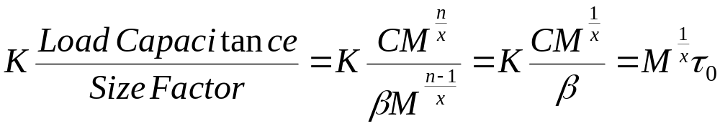
as the delay of τ_{o} is for the ratio C/β. As delay of every stage is the same and there are x stages, the total delay = τ = τ_{o} x
Find x which minimizes τ .
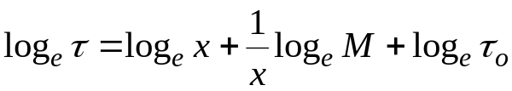
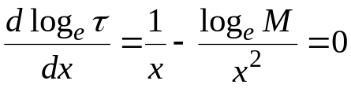
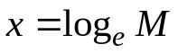
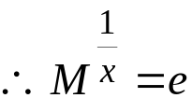
for optimum switching speed , each inverter should be
e times larger than the previous one.

Scaling of MOS Devices

Influence of first-order scaling on MOS device characteristics
 | PARAMETERS | SCALING  FACTOR
 | Length; L | 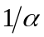
 | Width: W
DEVICE | Gate oxide thickness; t_{ox}
PARAMETERS | Junction depth; X_{j}
 | Substrate doping; N_{a (or b)}
 | Supply voltage; V_{DD}
 | Electric field across gate oxide; E | 1
 | Depletion layer thickness; d
 | Parasitic capacitance;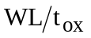
 | Gate delay; 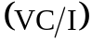
RESULTANT | DC power dissipation; P_{s} | 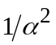
INFLUENCE | Dynamic power dissipation; P_{d}
 | Power-speed product | 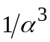
 | Gate area
 | Power density; 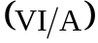 | 1
 | Current density; 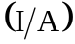
 | Transconductance; g_{m} | 1

In summary, CMOS technology offers tremendous power management advantage.
The switching characteristics and symmetric rise/fall delay dictate that the width of PMOS device is twice that of NMOS device in an inverter. Expressions for switching voltage and time delay can be derived for any simple MOSFET I-V model.

